**3rd Lab - Static Routing Based Multi Router Network Design and Configuration**

**Topology:**

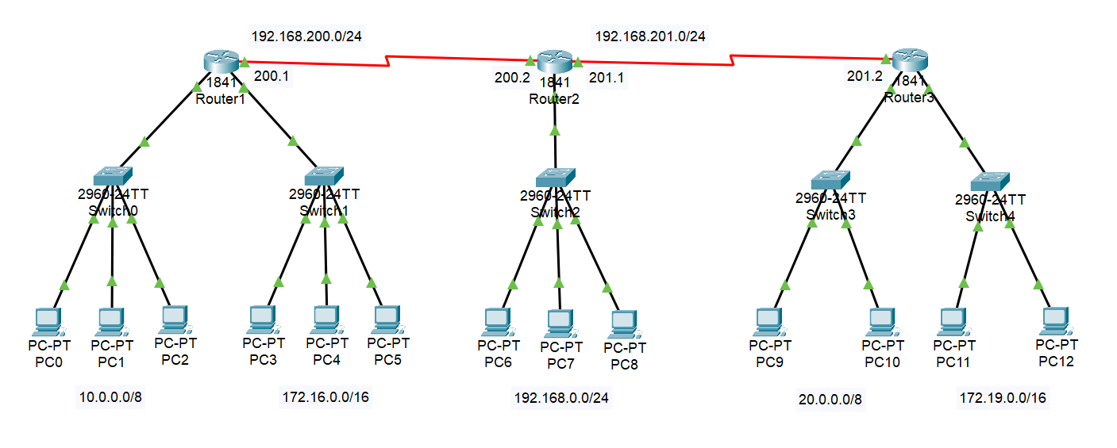

**Configure:**

1. Hostname (Router1, Router2 and Router3)
2. Interface fa, se (DCE, DTE)
3. PC IP Address
4. Static Routing

R1 → R2 R2 → R1 R3 → R1

→ R3 → R3 → R2

**Route:**

* ip route destn_NA destn_SM Next_Hop_Address

1. **Network Topology Overview:**

* Router1 is connected to Router2 via Serial0/0/0 ↔ Serial0/0/1
* Router3 is connected to Router2 via Serial0/0/0 ↔ Serial0/1/0
* Each router is connected to its own switches and hosts (PCs)
* All IP addresses are configured statically
* Static routing is used to ensure full connectivity between all devices

1. **IP Addressing Plan**

**Router 1:**

* **Switch 1 → 10.0.0.0/8**

PCs: 10.0.0.2–10.0.0.4

Gateway: 10.0.0.1

* **Switch 2 → 172.16.0.0/16**

PCs: 172.16.0.2–172.16.0.4

Gateway: 172.16.0.1

* **Serial to Router2 → 192.168.200.0/24**

Serial0/0/0: 192.168.200.1

**Router 2:**

* **Switch → 192.168.0.0/24**

PCs: 192.168.0.2–192.168.0.4

Gateway: 192.168.0.1

* **Serial0/0/1 (to Router1):** 192.168.200.2
* **Serial0/1/0 (to Router3):** 192.168.201.1

**Router 3:**

* **Switch 1 → 20.0.0.0/8**

PCs: 20.0.0.2–20.0.0.3

Gateway: 20.0.0.1

* **Switch 2 → 172.19.0.0/16**

PCs: 172.19.0.2–172.19.0.3

Gateway: 172.19.0.1

* **Serial0/0/0 (to Router2):** 192.168.201.2

1. **PC Configuration (example for 1 PC per network)**

Go to **PC > Desktop > IP Configuration** and set:

|  |  |  |  |
| --- | --- | --- | --- |
| **Network** | **PC IP** | **Subnet Mask** | **Default Gateway** |
| 10.0.0.0/8 | 10.0.0.2 | 255.0.0.0 | 10.0.0.1 |
| 172.16.0.0/16 | 172.16.0.2 | 255.255.0.0 | 172.16.0.1 |
| 192.168.0.0/24 | 192.168.0.2 | 255.255.255.0 | 192.168.0.1 |
| 20.0.0.0/8 | 20.0.0.2 | 255.0.0.0 | 20.0.0.1 |
| 172.19.0.0/16 | 172.19.0.2 | 255.255.0.0 | 172.19.0.1 |

1. **Router Configuration (CLI)**

**Router 1:**

Router> enable

Router# configure terminal

Router(config)# hostname Router1

Router1(config)# interface FastEthernet0/0

Router1(config-if)# ip address 10.0.0.1 255.0.0.0

Router1(config-if)# no shutdown

Router1(config-if)# exit

Router1(config)# interface FastEthernet0/1

Router1(config-if)# ip address 172.16.0.1 255.255.0.0

Router1(config-if)# no shutdown

Router1(config-if)# exit

Router1(config)# interface Serial0/0/0

Router1(config-if)# ip address 192.168.200.1 255.255.255.0

Router1(config-if)# clock rate 250000

Router1(config-if)# no shutdown

Router1(config-if)# exit

Router1(config)# ip route 192.168.0.0 255.255.255.0 192.168.200.2

Router1(config)# ip route 20.0.0.0 255.0.0.0 192.168.200.2

Router1(config)# ip route 172.19.0.0 255.255.0.0 192.168.200.2

Router1(config)# Ctrl + Z

Router1# write

**Router 2:**

Router> enable

Router# configure terminal

Router(config)# hostname Router2

Router2(config)# interface FastEthernet0/0

Router2(config-if)# ip address 192.168.0.1 255.255.255.0

Router2(config-if)# no shutdown

Router2(config-if)# exit

Router2(config)# interface Serial0/0/1

Router2(config-if)# ip address 192.168.200.2 255.255.255.0

Router2(config-if)# no shutdown

Router2(config-if)# exit

Router2(config)# interface Serial0/1/0

Router2(config-if)# ip address 192.168.201.1 255.255.255.0

Router2(config-if)# no shutdown

Router2(config-if)# exit

Router2(config)# ip route 10.0.0.0 255.0.0.0 192.168.200.1

Router2(config)# ip route 172.16.0.0 255.255.0.0 192.168.200.1

Router2(config)# ip route 20.0.0.0 255.0.0.0 192.168.201.2

Router2(config)# ip route 172.19.0.0 255.255.0.0 192.168.201.2

Router2(config)# Ctrl + Z

Router2# write

**Router 3:**

Router> enable

Router# configure terminal

Router(config)# hostname Router3

Router3(config)# interface FastEthernet0/0

Router3(config-if)# ip address 20.0.0.1 255.0.0.0

Router3(config-if)# no shutdown

Router3(config-if)# exit

Router3(config)# interface FastEthernet0/1

Router3(config-if)# ip address 172.19.0.1 255.255.0.0

Router3(config-if)# no shutdown

Router3(config-if)# exit

Router3(config)# interface Serial0/0/0

Router3(config-if)# ip address 192.168.201.2 255.255.255.0

Router3(config-if)# clock rate 250000

Router3(config-if)# no shutdown

Router3(config-if)# exit

Router3(config)# ip route 10.0.0.0 255.0.0.0 192.168.201.1

Router3(config)# ip route 172.16.0.0 255.255.0.0 192.168.201.1

Router3(config)# ip route 192.168.0.0 255.255.255.0 192.168.201.1

Router3(config)# Ctrl + Z

Router3# write

1. **Ping Test (Check Connectivity from Command Prompt)**

* PC0 > ping 192.168.0.2
* PC6 > ping 172.16.0.2
* PC9 > ping 10.0.0.2
* PC11 > ping 192.168.0.2